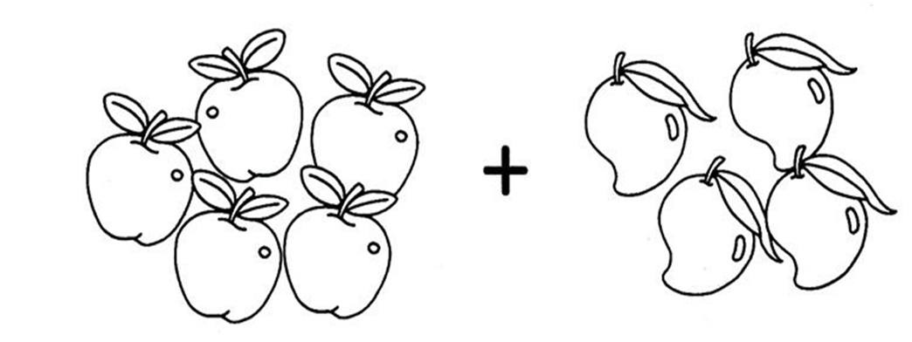

|  |  |  |  |  |
| --- | --- | --- | --- | --- |
|  |  |  | = |  |

|  |  |  |  |  |  |
| --- | --- | --- | --- | --- | --- |
| 9 |  | 8 |  | 14 |  |
|  | 2 |  | 13 |  | 6 |
| 15 |  | 4 |  | 11 |  |